ASSISTED LISTENING & AUDIO DESCRIPTION CUSTOMER GUIDE

At The Bridge, we use an innovative digital radio frequency system for Assisted Listening and Audio Description.

Our Sennheiser radio receivers give patrons access to Assisted Listening for every performance. A full list of upcoming Access Performances can be found on the Access section of our website.

Devices are available to be collected from the Box Office, with headphones or induction neck loops.

We have headphones available for use with these, both in-ear and over-ear, though you are welcome to bring your own headphones with you (wired headphones only with a standard 3.5mm jack - unfortunately Bluetooth and wireless headphones will not work with our system). Our devices can also be used with a loop (without headphones) if you have the correct T-setting on your hearing aid.

HOW TO USE:

You’ll find the On/Off button on the top of the device:
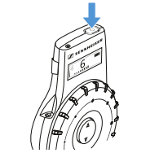

Below explains what each part of the device are for:

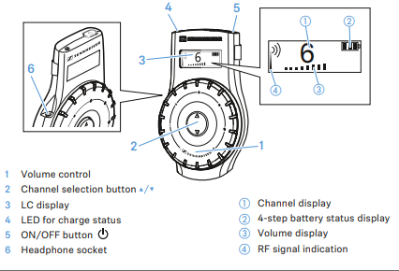

Choosing your channel:

- Channel 1 is for Assisted Listening only
- Channel 2 is for Assisted Listening & Audio Description
- Channel 3 is for Audio Description only (Audio description is only available at certain performances)
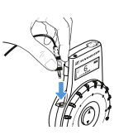

This is where you can plug your headphones in.

If you have not brought your own headphones then you will be given the following device which has headphones attached.
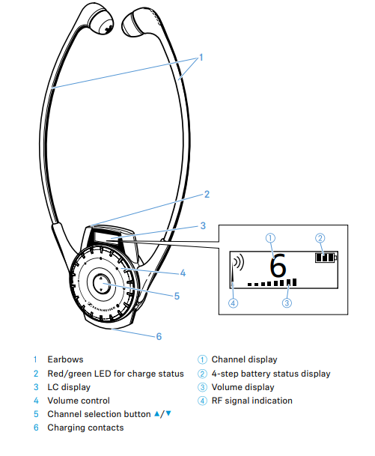

If you have any difficulties with your device, please let a member of staff know as soon as possible as they will be more than happy to assist you before the show begins.

All performances also have a dedicated Access Host who will be on hand to assist you during your visit and will also be more than happy to show you how to use your device.

If you have any questions in advance you can email access@bridgetheatre.co.uk.

